Chapter 6: The 555 Timer Chip Astable Circuit

Introduction

The 555 IC is unique in that it simply, cheaply, and accurately serves as a free-running astable multivibrator, square-wave generator, or signal source, as well as being useful as a pulse generator and serving as a solution to many special problems. It can be used with any power supply in the range 5-18 volts, thus it is useful in many analog circuits. When connected to a 5-volt supply, the circuit is directly compatible with TTL or CMOS digital devices. The 555 timer can be used as a monostable multivibrator (one-shot), as an astable multivibrator (oscillator), as a linear voltage ramp generator, as a missing pulse detector, as a pulse width modulator and in many other applications.
Clocked digital logic devices are synchronous with an internal clock of some form. Computer and real time clocks use crystal controlled oscillators as the internal standard. Slower devices such as digital multimeters and consumer electronics often use oscillators whose timing is dependent on the charging and discharging of a simple RC network. In this lab, we look at one such device, the 555 timer chip, as a free-running (astable) oscillator.

555 Timer Chip

The astable configuration of the 555 circuit, shown below uses two resistors and a capacitor to define the oscillator frequency. The voltage across the external capacitor is measured at the trigger and threshold inputs (pins 2 and 6 respectively). Depending on the magnitude of this voltage, an internal RS flip-flop may be set or reset. This output places the circuit into a charge or discharge cycle. On charging, the capacitor voltage rises to 2/3 Vcc and on discharge the capacitor voltage falls to 1/3 Vcc. At the upper limit, the threshold input turns off the internal flip-flop, and at the lower limit, the trigger input turns it on. The output voltage (pin 3) is a buffered copy of the flip-flop output and hence is a digital signal. The resulting pulse waveform defines the 555 oscillator signal.
Figure 6-1 The basic 555 astable circuit

The frequency of oscillation depends only on the resistor-capacitor chain (RA,RB,C) and is independent of the power supply voltage Vcc.

On charging, the external capacitor C charges through resistors RA and RB. The charging time t1 is given by
t1 = 0.693 (RA + RB) C Equation 6.1

and this part of the cycle is signaled by a high level on the output (pin3).

On discharge, the external capacitor C discharges through the resistor RB into pin 7 which is now connected internally to ground. The discharge time is given by

t2 = 0.695 RB C Equation 6.2

and this part of the cycle is signaled by a low level on the output.

The total time for one oscillation (the period T) is given by the sum of these two times

T = t1 + t2 = 0.695(RA + 2RB) C Equation 6.3

The frequency F is given by the reciprocal of the period, or

F = 1.44/(RA + 2RB)C . Equation 6.4

With the appropriate choices of external timing components, the period of the oscillation can range from microseconds to hours.

The duty cycle DC is the ratio of the time the output is low as compared to the period

DC = RB/(RA + 2RB) Equation 6.5

The duty cycle is always less than 50% or saying it another way, the off time t2 is always less than the on time t1. Thus the output of the 555 astable circuit is asymmetric. By making RB large compared to RA, the waveform becomes more symmetric and the 555 output approaches a square wave.

LabVIEW Demo 6.1: The 555 Astable Oscillator Circuit

Load the program called 555Astable1.vi from the chapter 6 program library. Click on the [Run] button to activate the astable circuit. The output on pin 3 is a digital signal, it is either a high or low level.

Investigate how the output waveform changes with different values of RA, RB or C.

Observe the output waveform and the duty cycle in the following cases:

1) RA > RB,
2) RA < RB,
and 3) RA = RB.

Figure 6-2 LabVIEW Simulation for a 555 Astable circuit

A variable frequency source can be made by selecting capacitors whose values are decades (factors of ten) different from each other and a variable resistor for fine frequency tuning. In practice, RA and RB can have a resistance from 1 kΩ to 10 MΩ and the capacitor can range from 0.001 to 100 μf. These combinations give the 555 astable circuit truly a very wide frequency range.

How Does it Work ?

The 555 timer is based on the sequential charging and discharging of the external capacitor. Two internal op-amps configured as comparators set the lower and upper voltage limits to 1/3 V_{cc} and 2/3 V_{cc}. The voltage across a capacitor at any time t is given by the expression

V(t) = V(0) exp(-t/RC) Equation 6.6

where V(0) is the initial voltage and RC is a charging/discharge time constant.

LabVIEW Demo 6.2: 555 Astable Oscillator Timing Diagram

Load the program called 555Astable2.vi from the chapter 6 program library. Click on the [Run] button to activate the astable circuit. The timing diagrams for the output voltage (pin 3) and the capacitor voltage (pins 2 & 6) have been added to the front panel display.
While the output (pin 3) is high, the power supply (taken here as +5 volts) charges the capacitor through the resistors RA and RB and the capacitor voltage rises exponentially. When the voltage across the capacitor reaches a reference voltage of 2/3 V_{cc} (3.33 volts), the threshold comparator (at pin 6) triggers an internal flip-flop which resets the output (pin 3) low and starts the discharge cycle. The voltage at the upper limit is

  - 3.33 = 1.67 exp(-t1/[RA +RB]C) Equation 6.7

Solving for t1 in equation 6.1 yields the time interval that the capacitor is charging. The timing diagram shows the charging cycle (green trace - capacitor voltage) as a positive ramp when the astable output (red trace - output pin 3) is at the high level. The two comparator limits 1/3 V_{cc} and 2/3 V_{cc} are shown as horizontal lines (white traces).

Figure 6-3 LabVIEW Display of the Charge and Discharge Cycles for a 555 Astable circuit

When the capacitor voltage reaches the upper reference limit, the power supply is effectively removed from the capacitor circuit and pin 7 becomes internally connected to ground. The capacitor is allowed to discharge through the single resistor RB. The discharge voltage at the lower limit is

1.67 = 3.33 exp(-t2/RBC) Equation 6.8

where t2 is the discharge time constant. In the discharge cycle, the capacitor voltage ramps down (green trace) to the lower limit (1/3 V_{cc}). At this point the trigger comparator (pin 2) sets the flip-flop back to its high state and the cycle repeats.

LED Flasher

A flashing alert signal can be generated by driving a light emitting LED diode with a 555 astable circuit. The output (pin 3) is capable of sourcing a few milliamps or sinking up to 200 milliamps, more than enough current to brightly illuminate any light emitting diode.

LabVIEW Demo 5: The 555 LED Flasher Circuit
Load the program called 555Flasher.vi from the chapter 6 program library. A LED has been added to pin 3 and pulled up to V_{cc} through a series resistor. Click on [Run] to observe the LED flashing. A logic probe has also been added to pin 3. Whenever the output is high, it is red and whenever the output is low, it is black. The LED has the opposite state. Whenever the output is high, it is gray (off) and whenever the output is low, it is yellow (on). The output timing diagram and a frequency counter have also been added to the circuit.

Figure 6-4 LabVIEW Simulation for a 555 LED Flasher Circuit

When the output (pin 3) is high, there is not enough voltage drop across the resistor and LED to turn the LED on. However when the output is low, current can flow through the LED (which is now forward biased) and into the output (pin 3) and out the ground lead (pin 1). The purpose of the resistor is to limit or to set the current when the LED is on. This resistor determines the brightness of the LED. Since the forward voltage across a silicon diode is 0.6 volts, and if the power supply is 5 volts, then (5 - 0.6) = 4.4 volts will be across the resistor. For a forward bias current of 13.3 ma (red LED brightly lit), the resistor should be about 330Ω.

Temperature Transducer

A transducer is an electronic circuit which converts a physical parameter such as temperature into an electrical signal so that it can be measured by conventional techniques. In this virtual experiment, a thermistor is used to convert temperature into a waveform whose off-time is directly proportional to temperature.

A thermistor is a device whose resistance is dependent on the device temperature. Thermistors are manufactured from semiconducting materials which accounts for their unusual conductivity.

Thermistors have three unique properties;
1) the sensitivity or the change in resistance per degree Centigrade is large,
2) the resistance decreases with increasing temperature (a negative temperature coefficient),
and 3) the resistance has a nonlinear exponential response curve (often over six decades).

LabVIEW Demo 5: Temperature Transducer
Load the program called Thermometer.vi from the chapter 6 program library. A thermistor labeled Rb has been placed into a beaker of water. A gas burner controlled by a rotary valve allows you to heat the water to a known themperature. A thermometer has been added to the beaker to measure this temperature and it can be used to calibrate the thermistor. The thermistor replaces the resistor RB in the 555 astable circuit. When run, the waveform will be displayed on an [Output vs Time] chart. By clicking and dragging the cursors, you can place the cursors on the appropriate transition to measure a time interval Δt = t2-t1. You can measure the on-time, the off-time or the period. Activate the experiment by clicking on the [Run] button. Watch the waveform change as the liquid is heated or cooled by changing the gas flow.

Figure 6-5 LabVIEW Simulation to Measure the Heating or Cooling Curve of Water

To measure the off-time, click and drag the cursor T1 to a falling edge and T2 to the adjacent rising edge such that T2>T1 and read the time from Δt indicator display.

Plot a graph of off-time of the thermistor circuit versus temperature as measured by the thermometer. Is this graph linear or nonlinear? Using equation 6-2 and other component values (given in the above diagram), calculate the resistance of the thermistor for each temperature measurement.

LabVIEW Exercise: Plot a graph of the thermistor resistance versus temperature for this sensor to reveal the unique properties of a thermistor.

eLab Project 6

Objective: To study the waveforms from a 555 astable oscillator and its frequency, period and duty cycle dependence on a external chain of resistors and a capacitor.

Procedure: Build a LED flasher based on the circuit of figure 6-1. Connect a 330 Ω resistor and red LED to the output (pin 3). Set RA = 3.3 kΩ, RB = 33 kΩ and C = 0.1 μF. The IC pinout and components can also be seen on the front panel of the program 555Flasher.vi, figure 6-4. The component layout is shown below.

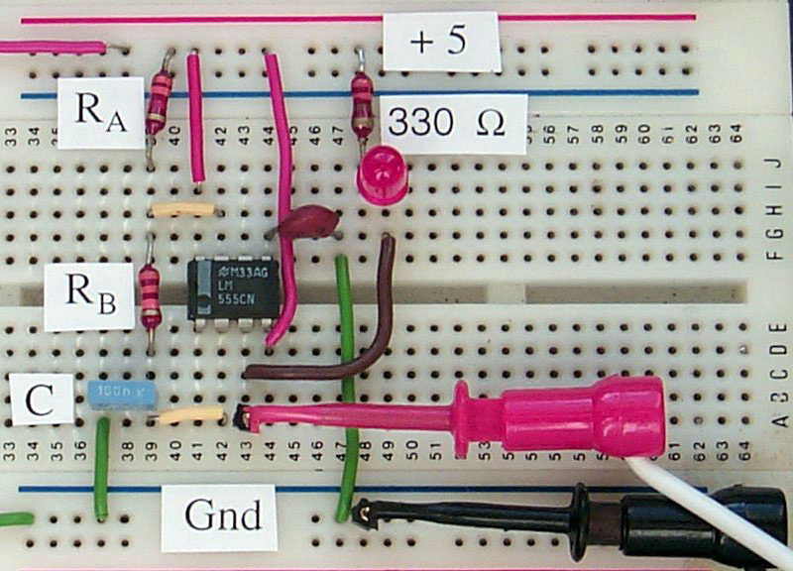

Figure 6-6 Component layout of a LED Flasher Circuit using the 555 Timer IC

Measure RA, RB and C separately before adding them into the circuit. Use equations 6.3 - 6.5 to predict the oscillation period, the frequency and the duty cycle. Measure these same quantities on the output (pin 3) of the 555 IC. How close do the measured parameters agree with the calculated values?

Describe the appearance of the LED light.
Replace the 0.1 μF capacitor with a 1 μF capacitor and now describe the appearance of the LED light.

Computer Automation 6 : Digital Signals

For digital signals, the amplitude is a constant and all information is carried in the time response be it frequency, period or duty cycle. In this lab, we will measure the digital frequency produced by a 555 timer chip driven from a +5 volt power supply. Use the eLab project 6 as the starting circuit. As in the eLab 6, choose RA = 3.3 kΩ, RB = 33 kΩ and C = 0.1 μF. Remove the LED from the circuit.

Launch the LabVIEW program entitled FrequencyLow.vi from the chapter 6 library. This program uses three internal counters on the DAQ card to measure TTL level digital signals in the frequency range f< 1 kHz. Ensure that the counters are connected externally as indicated on the front panel diagram.

Note: That an external 7404 hex inverter chip is also required.

Connect the 555 output (pin 3) to the Counter2 input on the DAQ card.

Click on [Run] to make a frequency measurement. Verify that the measured frequency agrees with your frequency prediction based on the component values of RA, RB and C.

Circuit Enhancements
Replace the resistor with a variable resistor in the range 10–100 kΩ, and investigate the changes in frequency as the resistor is adjusted.
Replace the resistor with a thermistor or a photoresistor and investigate the changes in frequency with temperature or light intensity.

LabVIEW Enhancements

For frequencies greater the 1 kHz, a different VI is used.
Check your LabVIEW/examples/daq/counter library for a Vi called
(Measure Frequency >1kHz.vi).

Note that different DAQ cards may use different timers.
Ensure you are using the correct library; 8253.llb or AMD9513.llb or DAQ-STC.llb

